**Projet Graphical Identity**

1. **Logo**
2. **Colors**

Accent 3

Secondary

Accent 2

Accent 1

Primary

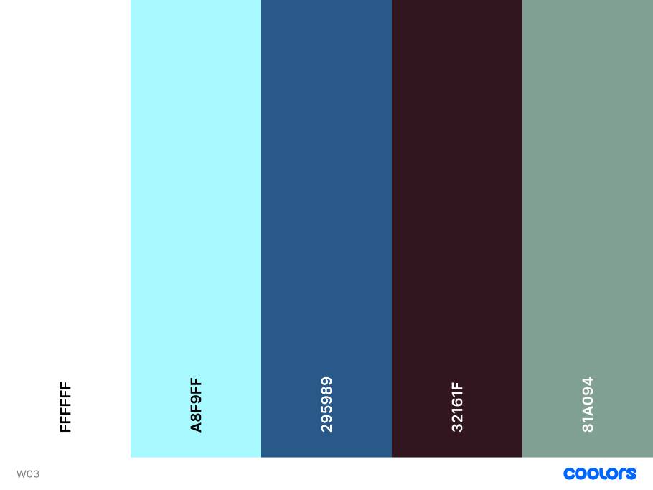

1. **Typography**

* Heading-font: **Roboto:ital,wght@0,100;0,300;0,400;0,500;0,700;0,900**
* Paragraph-font : **Open Sans:ital,wght@0,300..800;1,300..800**

1. **Coolors** **URL**

Color palette URL : <https://coolors.co/ffffff-a8f9ff-295989-32161f-81a094>